eProsima RPC over DDS
Installation Manual
Version 0.0.0


The Middleware Experts
eProsima © 2014

eProsima
Proyectos y Sistemas de Mantenimiento SL
Ronda del poniente 16 – Bajo K
28760 Tres Cantos Madrid
Tel: + 34 91 804 34 48
info@eProsima.com – www.eProsima.com

Trademarks
eProsima is a trademark of Proyectos y Sistemas de Mantenimiento SL. All other trademarks used in this document are the property of their respective owners.

License
eProsima RPC over DDS is licensed under the terms described in the RPCDDS_LICENSE file included in this distribution.

Technical Support
- Phone: +34 91 804 34 48
- Email: Support@eProsima.com

Table of Contents
eProsima RPC over DDS 1
1 Basic Requirements 4
1.1 Windows 7 32-bit and 64-bit 4
1.1.1 RTI Connext DDS 5.1.0 4
1.1.2 Visual C++ 2010 Redistributable package installation 4
1.2 Fedora 20 32-bit and 64-bit 4
1.2.1 RTI Connext DDS 5.1.0 4
1.2.2 Boost 5
1.3 Other Linux distribution 5
1.3.1 RTI Connext DDS 5.1.0 5
1.3.2 Boost 5
2 Installation 6
2.1 Windows 7 32-bit and 64-bit 6
2.2 Fedora 20 32-bit and 64-bit 7
2.3 Other Linux distribution 32-bit and 64-bit 8

Basic Requirements
This section describes the basic requirements of eProsima RPC over DDS and how to install them.

Windows 7 32-bit and 64-bit

RTI Connext DDS 5.1.0
eProsima RPC over DDS uses the types defined in RTI Connext DDS 5.1.0, so it must be installed. Install RTI Connext DDS for Win32 or Win64 (depending on your Operating System) with the corresponding installer.

The NDDSHOME environment variable needs to be set to the RTI Connext DDS installation folder. An example is shown below:

set NDDSHOME=C:\Program Files\RTI\ndds.5.1.0

The PATH environment variable should also contain the location of the RTI Connext DDS libraries for platform i86Win32VS2010 (32-bit machine) or x64Win64VS2010 (64-bit machine).

set PATH=%PATH%;%NDDSHOME%\lib\architecture

Visual C++ 2010 Redistributable package installation
eProsima RPC requires Visual C++ Redistributable package. This distribution checks if it is present in the system. If the package is not present, this distribution prompts the user to install it.

Fedora 20 32-bit and 64-bit

RTI Connext DDS 5.1.0
eProsima RPC over DDS uses RTI Connext DDS 5.1.0 as the communication engine. Its libraries and tools must be installed. Install RTI Connext DDS for Linux platform i86Linux2.6gcc4.4.5 with the corresponding installer.

The environment variable NDDSHOME needs to be set to the RTI Connext DDS installation folder. An example is shown below:
export NDDSHOME=/opt/RTI/ndds.5.1.0

Also the environment variable PATH and LD_LIBRARY_PATH have to contain the location of the RTI Connext DDS libraries for platform i86Linux2.6gcc4.4.5.
export PATH=$PATH:$NDDSHOME/lib/i86Linux2.6gcc4.4.5
export LD_LIBRARY_PATH=$LD_LIBRARY_PATH:$NDDSHOME/lib/i86Linux2.6gcc4.4.5

Boost
eProsima RPC over DDS uses Boost libraries. Install them using the Fedora package manager.
yum install boost-date-time boost-chrono boost-system boost-thread

Other Linux distribution

RTI Connext DDS 5.1.0
eProsima RPC over DDS uses RTI Connext DDS 5.1.0 as its communications engine. Its libraries and tools should be installed. Install RTI Connext DDS for Linux platform i86Linux2.6gcc4.4.5 with the corresponding installer.

The environment variable NDDSHOME needs to be set to the RTI Connext DDS installation folder. An example is shown below:
export NDDSHOME=/opt/RTI/ndds.5.1.0

Also the environment variable PATH and LD_LIBRARY_PATH have to contain the location of the RTI Connext DDS libraries for platform i86Linux2.6gcc4.4.5.
export PATH=$PATH:$NDDSHOME/lib/i86Linux2.6gcc4.4.5
export LD_LIBRARY_PATH=$LD_LIBRARY_PATH:$NDDSHOME/lib/i86Linux2.6gcc4.4.5

Boost
eProsima RPC over DDS uses Boost libraries. Install them using the corresponding package manager.

Installation
This document describes how to install eProsima RPC over DDS in several operating systems. Select your operating system and follow the steps.

Windows 7 32-bit and 64-bit
Download the installation package for your system.
eProsima_RPCDDS-0.0.0-Windows-RTIDDS_5.1.0.exe

Execute the installer and follow the instructions. You will be asked for some basic information, such as the installation location or the Start Menu folder.
You should make sure that at least one component is selected in the Choose Components step:
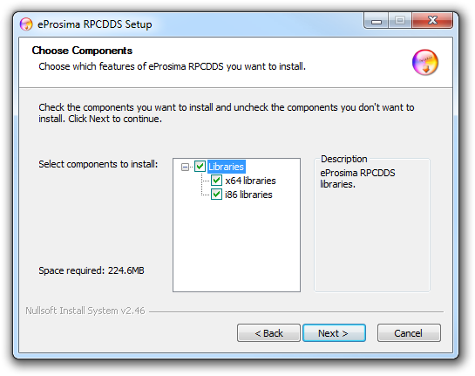
Once the main components have been selected click Next. Another page named Environment variable setting will be shown.
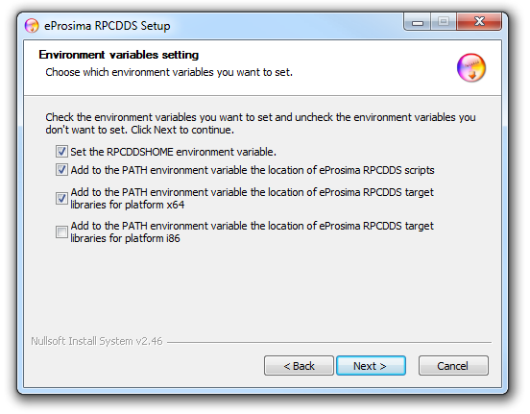
It is recommended to set the environment variable RPCDDSHOME and to make it point to the eProsima RPC over DDS installation folder. Make sure this option is selected in the Environment variable setting step.
It is also convenient to append the rpcddsgen executable location directory to the PATH environment variable of the system. Make sure this option is selected in the Environment variable setting step.
The serialization library should also be accessible for your system. The installer offers the possibility of appending the location of the libraries you selected to install to the PATH environment variable. Make sure this option is selected in the Environment variable setting step.

Fedora 20 32-bit and 64-bit
Download the installation package for your system.
eProsima_RPCDDS-0.0.0-Fedora20-RTIDDS_5.1.0.tar.gz

Extract its content.
Install the eProsima RPC over DDS repository with one of these commands, depending on your operating system architecture. These commands install eProsima RPC over DDS libraries. The headers will be installed in /usr/include/rpcdds and the libraries in /usr/lib64 (or /usr/lib if the library is installed in a 32-bit OS). They also install the rpcddsgen.sh script in /usr/bin, the examples in /usr/share/rpcdds and the documentation in /usr/share/doc/rpcdds.
yum localinstall i686/fastcdr-0.2.4-1.fc20.i686.rpm
yum localinstall i686/rpcdds-0.0.0-1.fc20.i686.rpm

yum localinstall x86_64/fastcdr-0.2.4-1.fc20.x86_64.rpm
yum localinstall x86_64/rpcdds-0.0.0-1.fc20.x86_64.rpm

Other Linux distribution 32-bit and 64-bit
Download the installation package for your system.
eProsima_RPCDDS-0.0.0-Linux-RTIDDS_5.1.0.tar.gz

Extract its content. First, install the eProsima FastCdr library needed by eProsima RPC over DDS. For 32-bit machines.
$ cd fastcdr; ./configure --libdir=/usr/lib; make; make install

For 64-bit machines.
$ cd fastcdr; ./configure --libdir=/usr/lib64; make; make install

Next, install the eProsima FastRTPS library needed by eProsima RPC over DDS. For 32-bit machines.
$ cd fastrtps; ./configure --libdir=/usr/lib; make; make install

For 64-bit machines.
$ cd fastrtps; ./configure --libdir=/usr/lib64; make; make install

Now, install the eProsima RPC over DDS software. For 32-bit machines.
$ cd rpcdds; ./configure --libdir=/usr/lib; make; make install

For 64-bit machines.
$ cd rpcdds; ./configure --libdir=/usr/lib64; make; make install

